A user of the [{ggalt} package](https://github.com/hrbrmstr/ggalt/) recently [posted a question](https://github.com/hrbrmstr/ggalt/issues/59) about how to add points to a geom_dumbbell() plot. For now, this is not something you can do with geom_dumbbell() but with a bit of data wrangling you can do this in a pretty straightforward manner with just your data and ggplot2. The example below uses 3 values per category but it should scale to n values per category (though after a certain n you should reconsider the use of a dummbell chart in favour of a more appropriate way to visualize the message you’re trying to convey).

Here’s the setup:

library(hrbrthemes)

library(tidyverse)

tibble(

val1 = c(3, 2, 4),

val2 = c(1, 4, 5),

val3 = c(5, 8, 6),

cat = factor(month.name[1:3], levels = rev(month.name[1:3]))

) -> xdf

Three values per category. The approach is pretty straightforward:

* reshape the data frame & get min value so you can draw an eye-tracking line (this is one geom)
* reshape the data frame & get min/max category values so you can draw the segment (this is another geom)
* reshape the data frame & plot the points

I’ve put ^^ notes near each ggplot2 geom:

ggplot() +

# reshape the data frame & get min value so you can draw an eye-tracking line (this is one geom)

geom_segment(

data = gather(xdf, measure, val, -cat) %>%

group_by(cat) %>%

top_n(-1) %>%

slice(1) %>%

ungroup(),

aes(x = 0, xend = val, y = cat, yend = cat),

linetype = "dotted", size = 0.5, color = "gray80"

) +

# reshape the data frame & get min/max category values so you can draw the segment (this is another geom)

geom_segment(

data = gather(xdf, measure, val, -cat) %>%

group_by(cat) %>%

summarise(start = range(val)[1], end = range(val)[2]) %>%

ungroup(),

aes(x = start, xend = end, y = cat, yend = cat),

color = "gray80", size = 2

) +

# reshape the data frame & plot the points

geom_point(

data = gather(xdf, measure, value, -cat),

aes(value, cat, color = measure),

size = 4

) +

# i just extended the scale a bit + put axis on top; choose aesthetics that work

# for you

scale_x_comma(position = "top", limits = c(0, 10)) +

scale_color_ipsum(name = "A real legend title") +

labs(

x = "Description of the value", y = NULL,

title = "A good plot title"

) +

theme_ipsum_rc(grid = "X") +

theme(legend.position = "top")

And, here’s the result:

[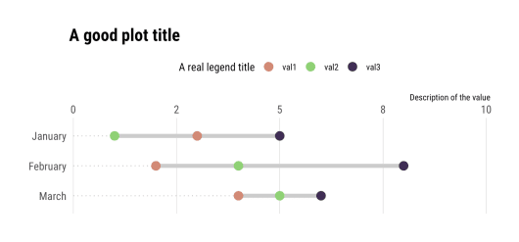](https://i1.wp.com/rud.is/b/wp-content/uploads/2019/06/there-are-three-points-2.png?ssl=1)